To begin completing the worksheet click **File** in the top left-hand corner and then choose **Make A Copy.**

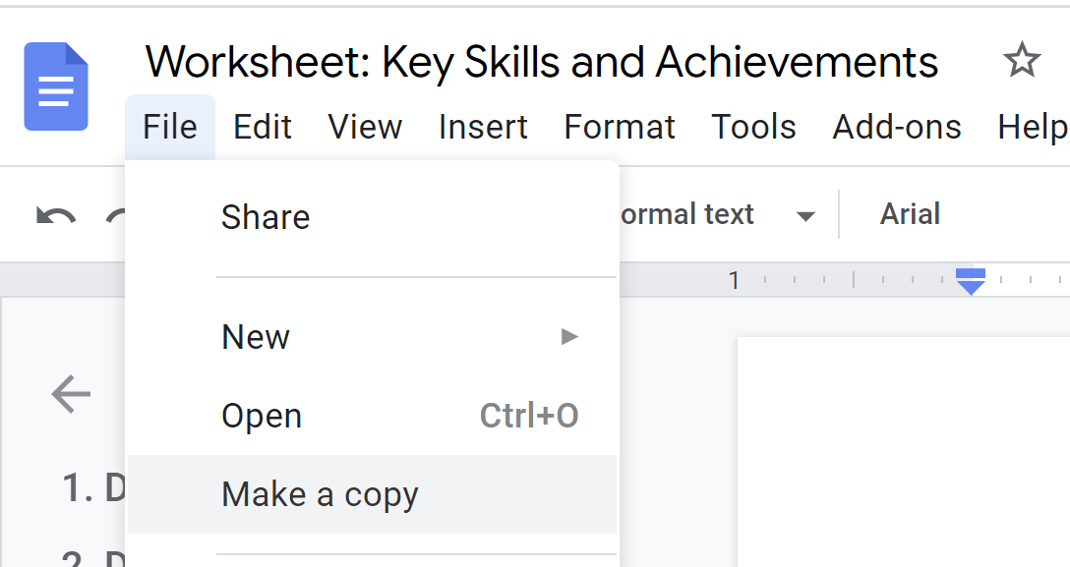

**Part 1: Adding numbers to your CV/Resume**

**Questions to help you along:**

1. Number of people you worked with?
2. Number of people you managed?
3. Number of people you hired/promoted?
4. Number of products/projects you managed?
5. No. Items of inventory managed?
6. Number of clients managed?
7. Number of new accounts signed up in 1 month?
8. Number of hours you saved?
9. Amount of money you saved?
10. Number of sales you made? What percent did you increase revenue by?
11. How much money did your department generate?
12. Reduced errors by X %?
13. Number of calls you made/customers served per day/per week
14. Attendance record % (90+)?
15. Won a contract worth €?
16. Number of people you presented to?
17. Number of people in group project?
18. Number of people you surveyed?
19. Client retention rate %?
20. Customer / service quality scores?
21. Maintained SLA rates?
22. Increased social media following by?
23. Words you can type per minute?
24. Number of calls/emails answered per day/week?
25. Positive Google reviews received?
26. Size of the budget you managed?
27. Number of direct reports you managed? Who was involved? (Stakeholders, management, etc).
28. Number of regions/stores/countries you oversaw?
29. Did you help get a grant approved? If so, how much?
30. What size is the company and how much annual revenue was generated last year?

**Part 2: Remembering your biggest wins**

**When writing out the answers do your best to explain:**

* What you did
* How you did it
* The result

**1. Did you create something new?**

* What did it do and what value did it bring?

**2. Did you solve a problem?**

* Think of a time when you went above and beyond your call of duty to find a solution to a problem?

**3. Did you come up with or improve an idea?**

* What did it do and what was its benefit?

**4. Did you help with something important or contribute to a key project?**

* What did the team or project achieve and what benefit did that bring to the organisation?

**5. Were you selected for something important or did you win an award or receive recognition?**

* What did you do that was recognised as valuable?

**6. Did you get strong feedback in a performance appraisal?**

* What did you do that your employer recognised?

**7. Did you excel in something?**

* Did you hold a perfect attendance record? Juggle multiple priorities? Score well on a test? Win rapid promotions?

### **Getting down to specifics:**

**8. Costs: Did you save an organisation money?**

* How did you save costs? Did you renegotiate contracts? Perform better budget monitoring? Source cheaper suppliers? Reduce costs from overtime?
* How much did you save? More than 10 percent? 500 $/€/£ a year?
* Were you or your team awarded a bonus/stock options?

**9. Service: Did you improve services?**

* How did you improve services? Did you create new service training? Perform better follow-up? Provide more personalised service? Improve service solutions?
* What was the result? A 20 percent increase in revenue? Greater customer loyalty? Improved customer experience?

**10. Quality: Did you improve quality?**

* How did you improve quality? Did you increase work checks? Create better training or systems? Improve planning?
* What was the result? A 10 percent reduction in re-work? A 20 percent reduction in waste? Errors cut by half? A reduction in customer complaints?

**11. Administration: Did you improve administration?**

* Did you improve records management systems? Did you create new templates? Did you bring in new computing systems?
* What was the result? Faster administrative processing time? A 20 percent reduction in errors? More professional communications? Quicker access to records?

**12. Productivity: Did you improve workplace productivity?**

* How did you improve productivity? Did you set up new training or systems? Provide clearer KPIs? Reorganise duties?
* What was the result? A 10 percent reduction in processing times? A 3 hour per week reduction? A 30-minute reduction in waiting time during peak periods?

**13. Money: Did you increase profit?**

* How did you increase profit? Did you revise pricing to improve margins? Perform tighter budget monitoring to reduce costs? Increase revenues through new sales strategies?
* What was the result? An increase of 10 percent in profit? Doubled profit? Improvement from loss to profit?

**14. Students/School Leavers: How did you perform in the school/academic environment?**

* How did you excel? Did you lead a team or project? Get exceptional results on an assignment? Take on extracurricular activities? Complete an industry-based assignment? Win an award? Get selected for something? Undertake additional studies? Mentor other students? Deliver presentations to large crowds? Conduct any research?
* What was the result? Recognition from a lecturer? Strong results on the assignment/subject? Additional skills? Improved marks?

**15. Targets**

* Think about a time you had a job, or other experience, where you had specific targets to reach.
* Did you achieve them? How did you achieve them?

**16. Doing a good job**

* Think about examples of times you've earned praise from others.
* What did you do, and what made it so good?

**17. Additional responsibilities**

* Have you ever taken on additional duties? What was the outcome?

**18. Review your past/current employer’s achievements**

* Review your past/current employer’s achievements - what was your contribution to the team? Did your department/company ever have a record-breaking month?
* While employed with the company, their success was your success!
  + Look at financial reports online to see profits during the period you were employed.
  + Review the company website or Google to find any past announcements of success.
  + Contact ex/current colleagues/managers and ask for results. Drop them a message on LinkedIn.
  + Estimate if you can’t get exact figures or data.

**For example:**

Extensive experience delivering on core responsibilities. Continuously provided constant and reliable administrative support to the marketing and HR departments responsible for €50,000 in monthly recurring revenue.